SF.SmokeTestScripts_TC_SF_OBRequiredFieldsOnSalesStage_Instance1_12-Apr-2017_09-49-50_PM_Invoke_Application.png



SF.SmokeTestScripts_TC_SF_OBRequiredFieldsOnSalesStage_Instance1_12-Apr-2017_09-50-04_PM_Login.png

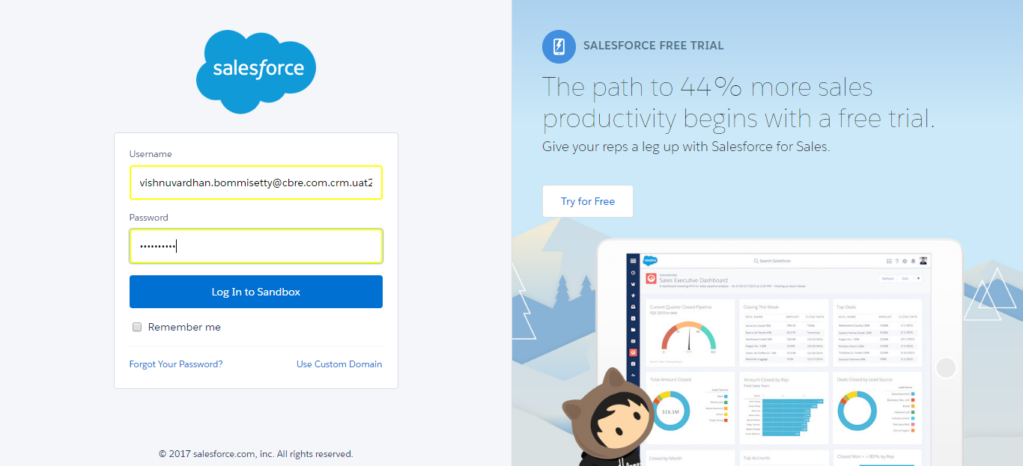

SF.SmokeTestScripts_TC_SF_OBRequiredFieldsOnSalesStage_Instance1_12-Apr-2017_09-50-18_PM_Verify_Login.png

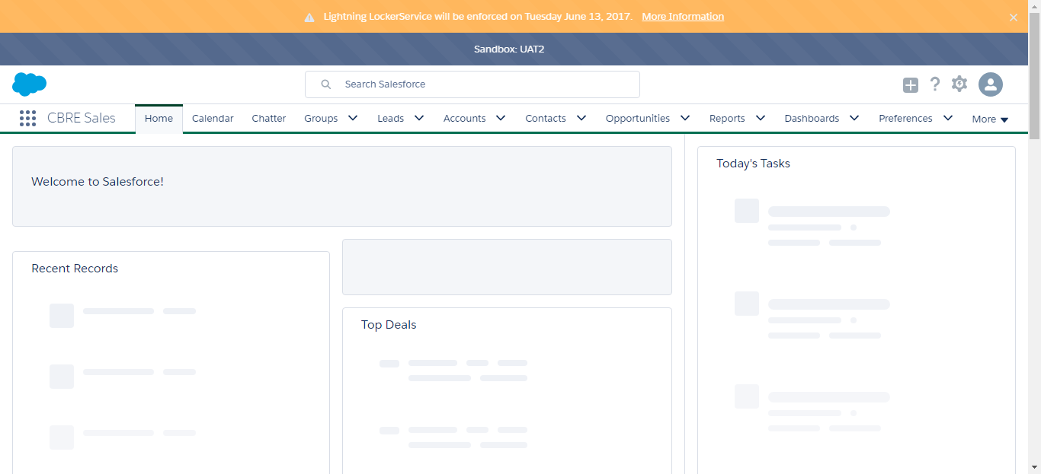

SF.SmokeTestScripts_TC_SF_OBRequiredFieldsOnSalesStage_Instance1_12-Apr-2017_09-50-22_PM_Verify_Fetch_Record.png

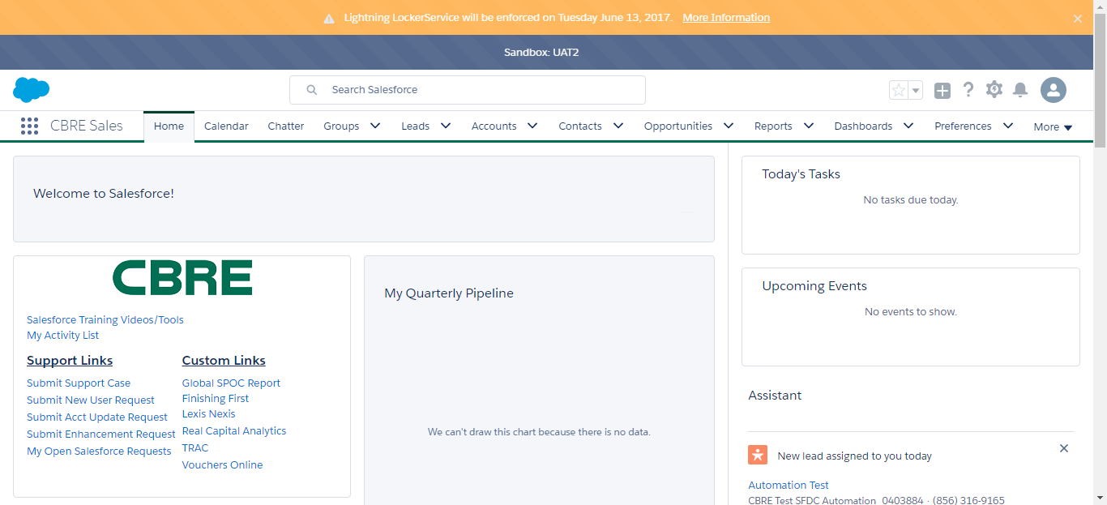

SF.SmokeTestScripts_TC_SF_OBRequiredFieldsOnSalesStage_Instance1_12-Apr-2017_09-50-25_PM_Verify_Add_Opportunity_Page



SF.SmokeTestScripts_TC_SF_OBRequiredFieldsOnSalesStage_Instance1_12-Apr-2017_09-50-25_PM_Verify_Opportunity_Required



SF.SmokeTestScripts_TC_SF_OBRequiredFieldsOnSalesStage_Instance1_12-Apr-2017_09-50-42_PM_Verify_Add_Opportunity_Page

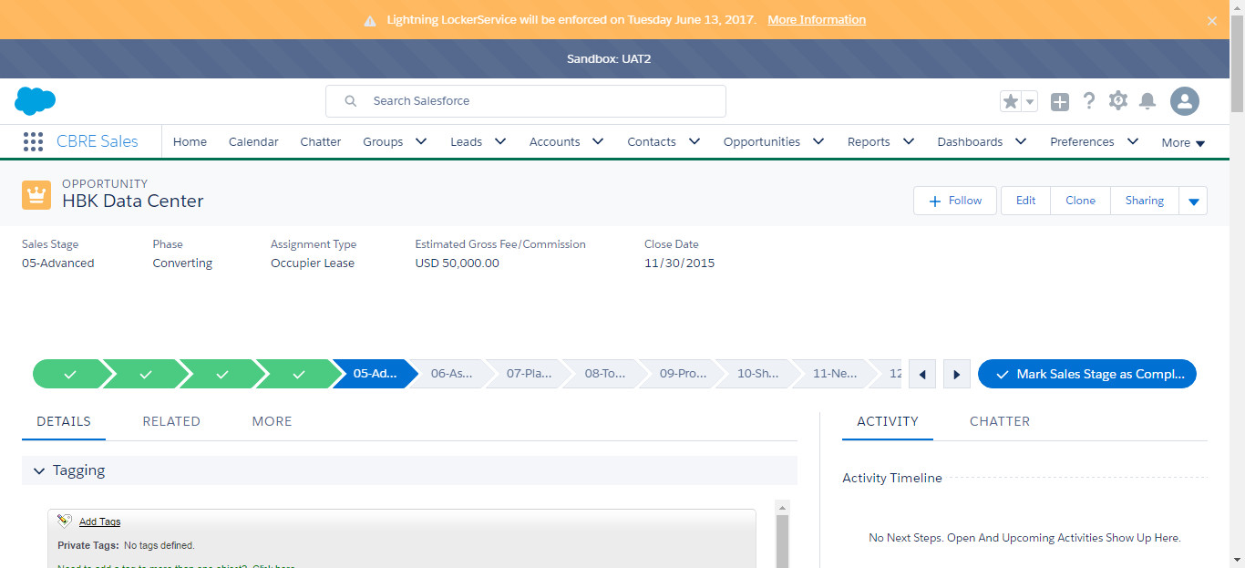

SF.SmokeTestScripts_TC_SF_OBRequiredFieldsOnSalesStage_Instance1_12-Apr-2017_09-52-23_PM_Error.png

